Data Scientist Technical Brief: IFTA Evidence Normalization, Analytics & Machine Learning
Prepared By: Pavan R. Hebbar
Domain Focus: International Fuel Tax Agreement (IFTA) Compliance Audit & Multi-Stage Anomaly Detection Pipeline
1. Multi-Modal Data Extraction and Processing Baseline
To handle the structural heterogeneity of the three source compliance logs, customized ingestion methodologies were deployed to normalize the data into a unified, clean operational baseline:
- Tabular Log Ledger ('Distance log 1.xlsx'): Because of its well-defined tabular structure, data ingestion was performed using the native vectorization features of pandas.read_excel() to preserve precise floating-point precision for mileage values.
- Scanned Documentation Images ('Distance log 2.pdf'): This artifact consists of low-fidelity, multi-page scanned distance logs. Ingestion required deploying an asynchronous optical character recognition (OCR) pipeline via AWS Textract. The documents were staged in an Amazon S3 bucket, processed via the start_document_analysis() API endpoint, and the resulting table blocks were structurally aligned and stitched across page breaks via DataFrame concats. Empty fields and duplicate logging lines were systematically dropped to prevent row inflation.
- Unstructured Receipt Repositories ('Fuel invoices.docx'): This document contains inline images of fuel receipts embedded within standard text. A preliminary pass using docx2txt isolated and extracted the raw imagery into a temporary directory. Each localized invoice was then passed through the AWS Textract expense parser using analyze_expense(). To ensure structural tracking, the pipeline captures summary_fields_list, line_item_groups, and raw lines for every document.
A deterministic data parsing engine maps these outputs against a rigid, standardized schematic dictionary (std_record):
std_record = {
'invoice_number': None, 'date': None, 'time': None,
'vendor_name': None, 'city': None, 'province': 'UNKNOWN',
'fuel_type': 'UNKNOWN', 'fuel_grade': 'UNKNOWN', 'quantity': None,
'cost_per_litre': None, 'cost': None, 'total_tax': None,
'fed_tax': None, 'prov_tax': None, 'payment_form': None
}
The engine iteratively crawls key arrays in the parsed response. If summary blocks fail to resolve, regular expression (Regex) pattern matches extract values from raw text before values are typed and normalized. The finalized dataframes are combined on historical transaction dates, preserving Textract OCR confidence indices for downstream data verification.
2. Engineered Feature Space & ML-Ready Target Dataset
The unified modeling matrix (df_ml_withfeatures) consists of 129 total entries structured across 40 distinct data columns.
Critical Analytical Insight (Sparsity Challenge):
Out of the 129 entries, only 10 possess an absolute matching fuel invoice record. Because commercial fleet assets refuel over large distance intervals and rarely after individual localized trip segments, single-trip ratio markers display heavy variance. This systemic baseline sparsity makes multi-scale moving temporal windows and jurisdictional vector tracking mathematically essential to isolate true anomalies from routine filling noise.
Comprehensive Target Dataset Schema Dictionary
Feature Space Column Key | Dtype Data Type | Pipeline Application & Functional Mechanics
trip_date | datetime64[ns] | Chronological index pairing log events with transaction markers.
trip_origin / trip_destination | object (str) | Geographical text identifiers for boundary tracing.
start_odometer / end_odometer | float64 | Raw instrumentation records confirming log line continuity.
total_km | float64 | The primary scalar distance leg tracked across the entire run unit.
ab_km / bc_km / mb_km / on_km | float64 | Physical distance segments mapped inside localized provincial lines.
ab_fuel / bc_fuel / mb_fuel / on_fuel | float64 | Volumetric fuel allocations tracked to localized transaction nodes.
matching_invoice_number | object (str) | Parsed financial receipt unique key string (None if unvouched).
invoice_date / _time / _location | object (str) | Spatial-temporal parameters derived from receipt OCR metadata blocks.
total_cost | float64 | Gross invoice currency paid for fuel allocations.
source_log | object (str) | Data provenance tag indicating source document lineage for audit tracing.
total_fuel_litres | float64 | Absolute gross volume of fuel associated with the trip records.
fuel_litres_per_km | float64 | Consumption efficiency ratio. Expected fleet envelope is 0.3 to 0.7 L/km.
fuel_cost_per_km | float64 | Financial efficiency ratio tracked on matched lines to catch unrecorded miles.
is_unvouched_trip | int64 (binary) | Logical marker indicating absolute absence of physical invoice verification.
{prov}_dist_prop | float64 | Fractional distance scalar indicating provincial footprint ratio inside travel zone.
{prov}_fuel_prop | float64 | Fractional fuel purchase scalar representing regional tax share ratios.
{prov}_dist_fuel_variance | float64 | Cross-examination vector mapping localized distance vs fuel parity errors.
weekly_avg_distance_km / _fuel_litres | float64 | Short-term 7-day asset-specific moving average background thresholds.
monthly_avg_distance_km / _fuel_litres | float64 | Structural 30-day asset-specific long-term background thresholds.

3. Two-Stage Anomaly Detection Pipeline
To enforce structural compliance, we deploy a hybrid Two-Stage Anomaly Detection Pipeline. This framework completely separates explicit, univariate process violations from subtle, latent statistical anomalies.
Stage 1: Deterministic Compliance & Z-Score Filtering
The dataset is first subjected to algorithmic rule checks. By dynamically extracting the moving standard deviation of the engineered features, the pipeline catches extreme outliers that cross the upper +3σ control boundaries. This phase strips away obvious process breaks, ensuring that massive univariate spikes do not apply heavy mathematical leverage to our machine learning model downstream.
Stage 2: Stochastic Machine Learning Isolation
Trips that pass through the initial deterministic filters are routed to an unsupervised Isolation Forest ensemble. While Stage 1 is optimal for capturing single-dimension thresholds, the Isolation Forest isolates complex, multi-dimensional anomalies. It exploits the fact that data points displaying unusual feature interactions require fewer recursive splits to isolate, causing them to emerge closer to the root nodes of the trees with highly negative anomaly scores.
4. Deep Forensic Interpretation & Explainability Analysis
Part A: Rule-Based Diagnostics (Stage 1)
Five specific trips were flagged during the deterministic filtering pass, exposing clear operational breakdowns:
- Severe Mileage Omission (2016-03-16 | Caledon -> Red Deer): Logs a cross-country distance of 3,250 km alongside a fuel volume of just 46 L. This represents a physical impossibility for a commercial truck, confirming unsubmitted fuel invoices.
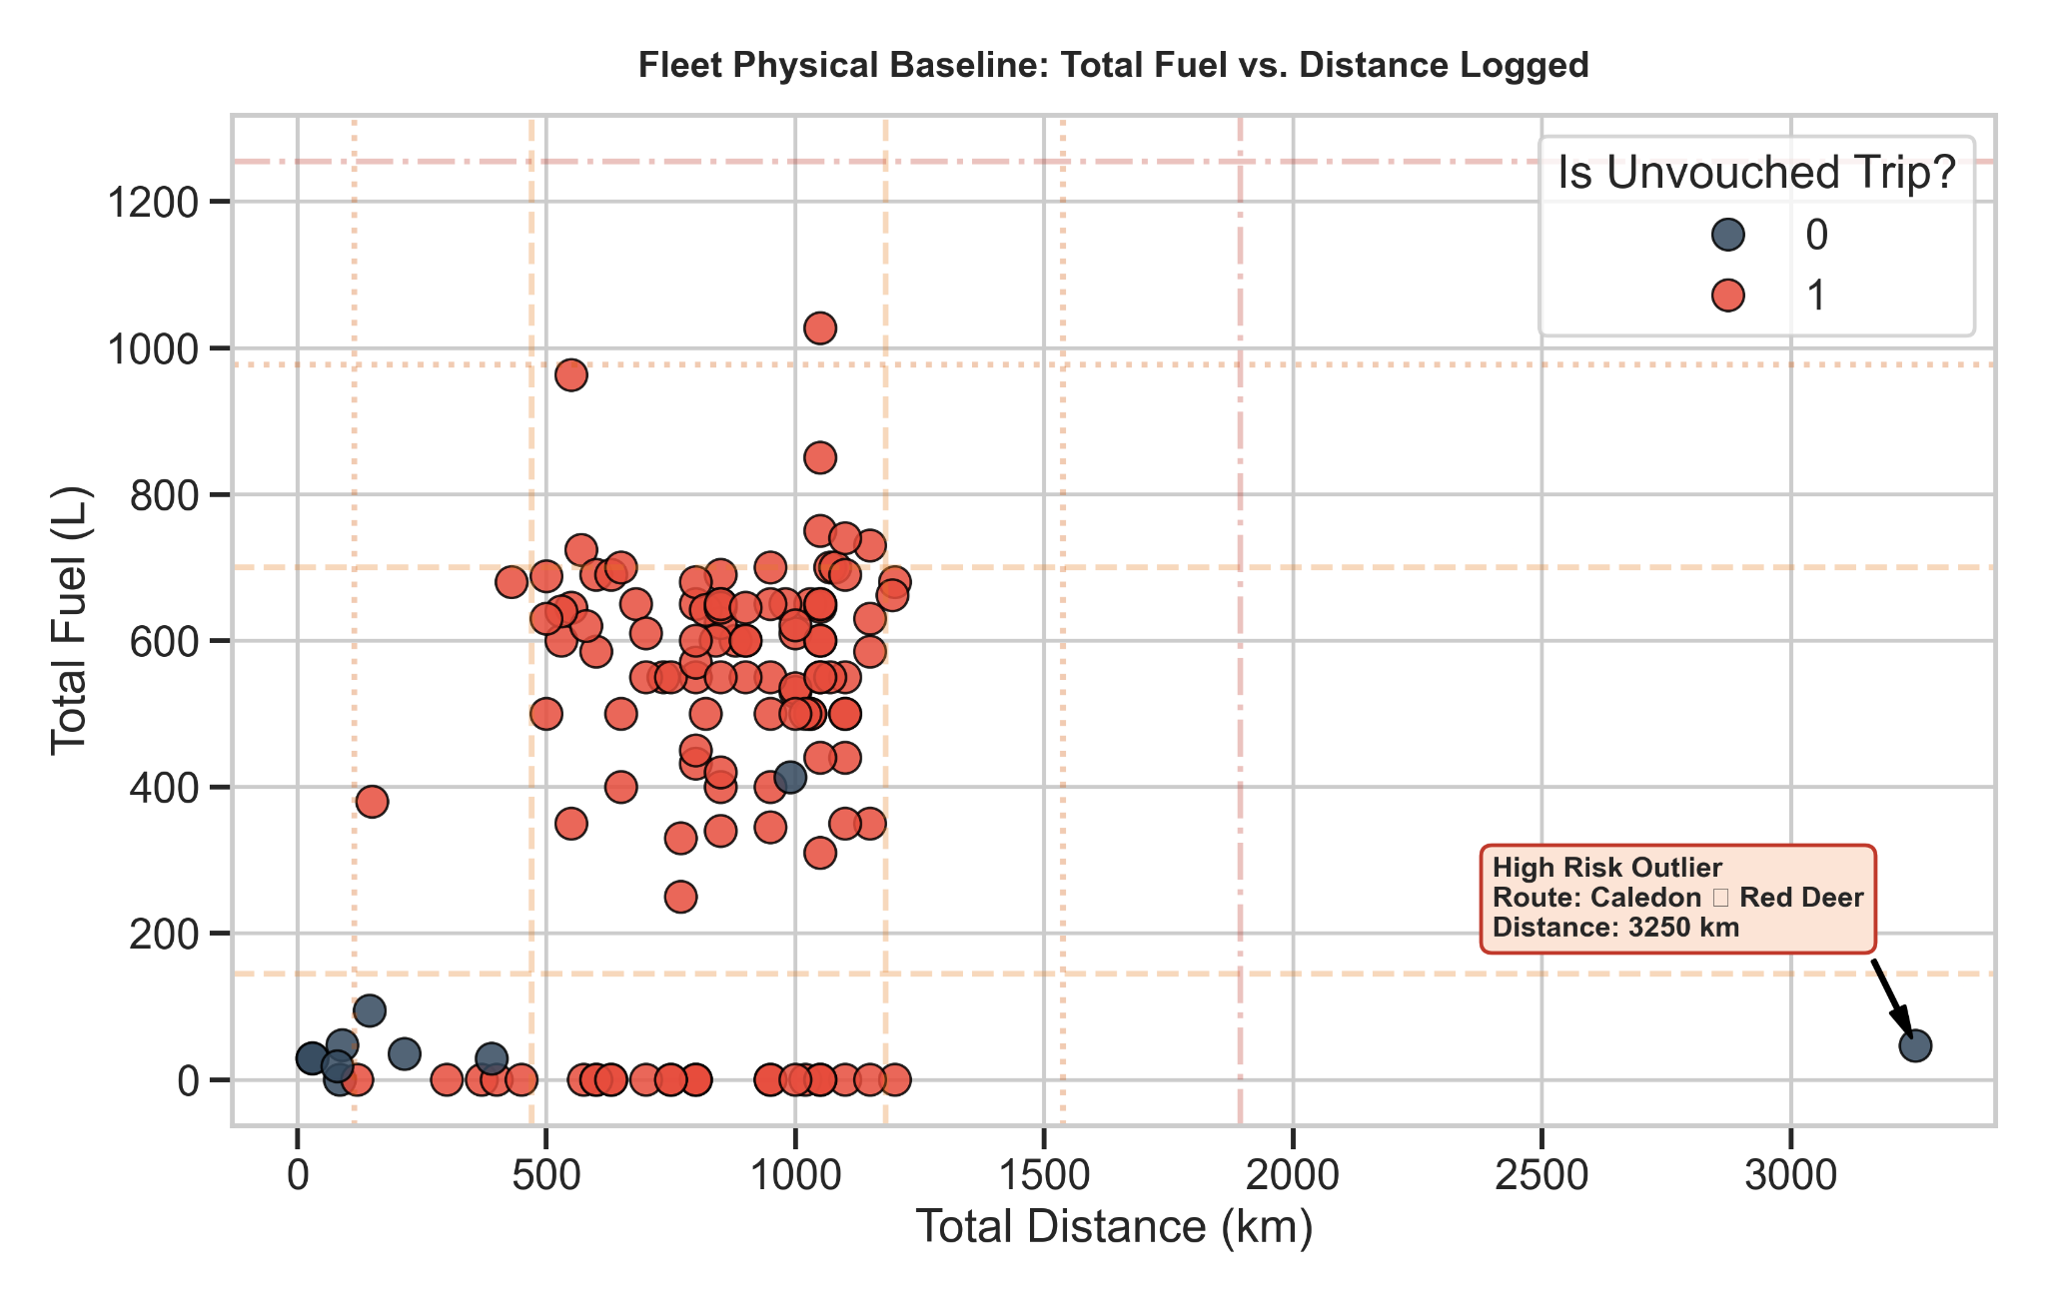
- Geographic Parity Breach (2022-01-06 | Valemount, BC -> Nisku, AB): The asset recorded 100% of its fuel purchases in Alberta (ab_fuel_prop = 1), yet logged 0% of its distance there (ab_dist_prop = 0). This severe cross-border mismatch represents an explicit IFTA compliance risk indication missing distance logs.
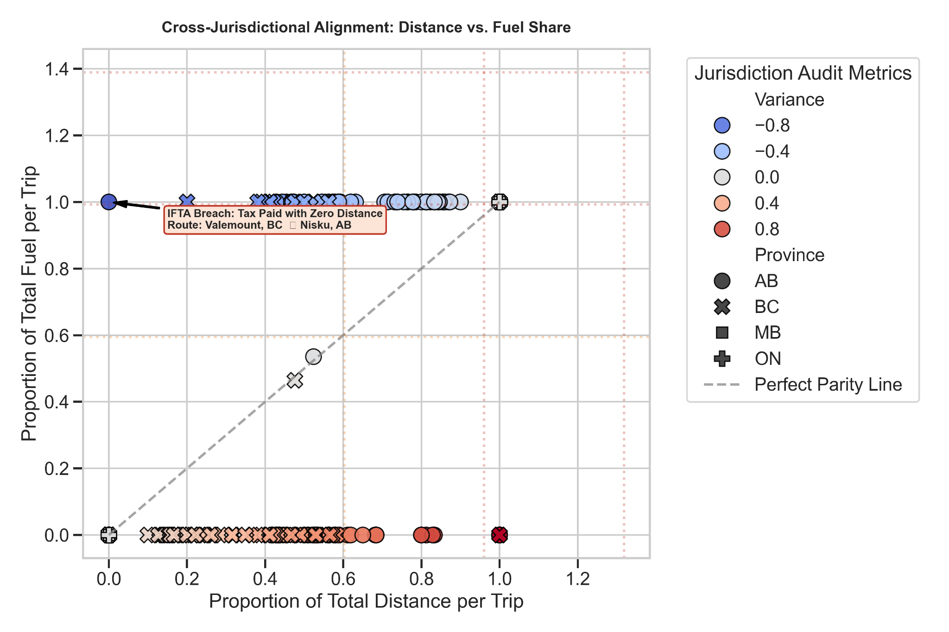
- Temporal Multi-Trip Ingestion Error (2022-02-13 | Nisku to Kamloops -> Williams Lake, BC): The trip distance spiked to exactly 4.0x the vehicle's historical moving weekly average. Because all normal fleet baselines sit comfortably below 2.5x variance, this profile indicates that operators batched multiple physical travel legs under a single date entry.
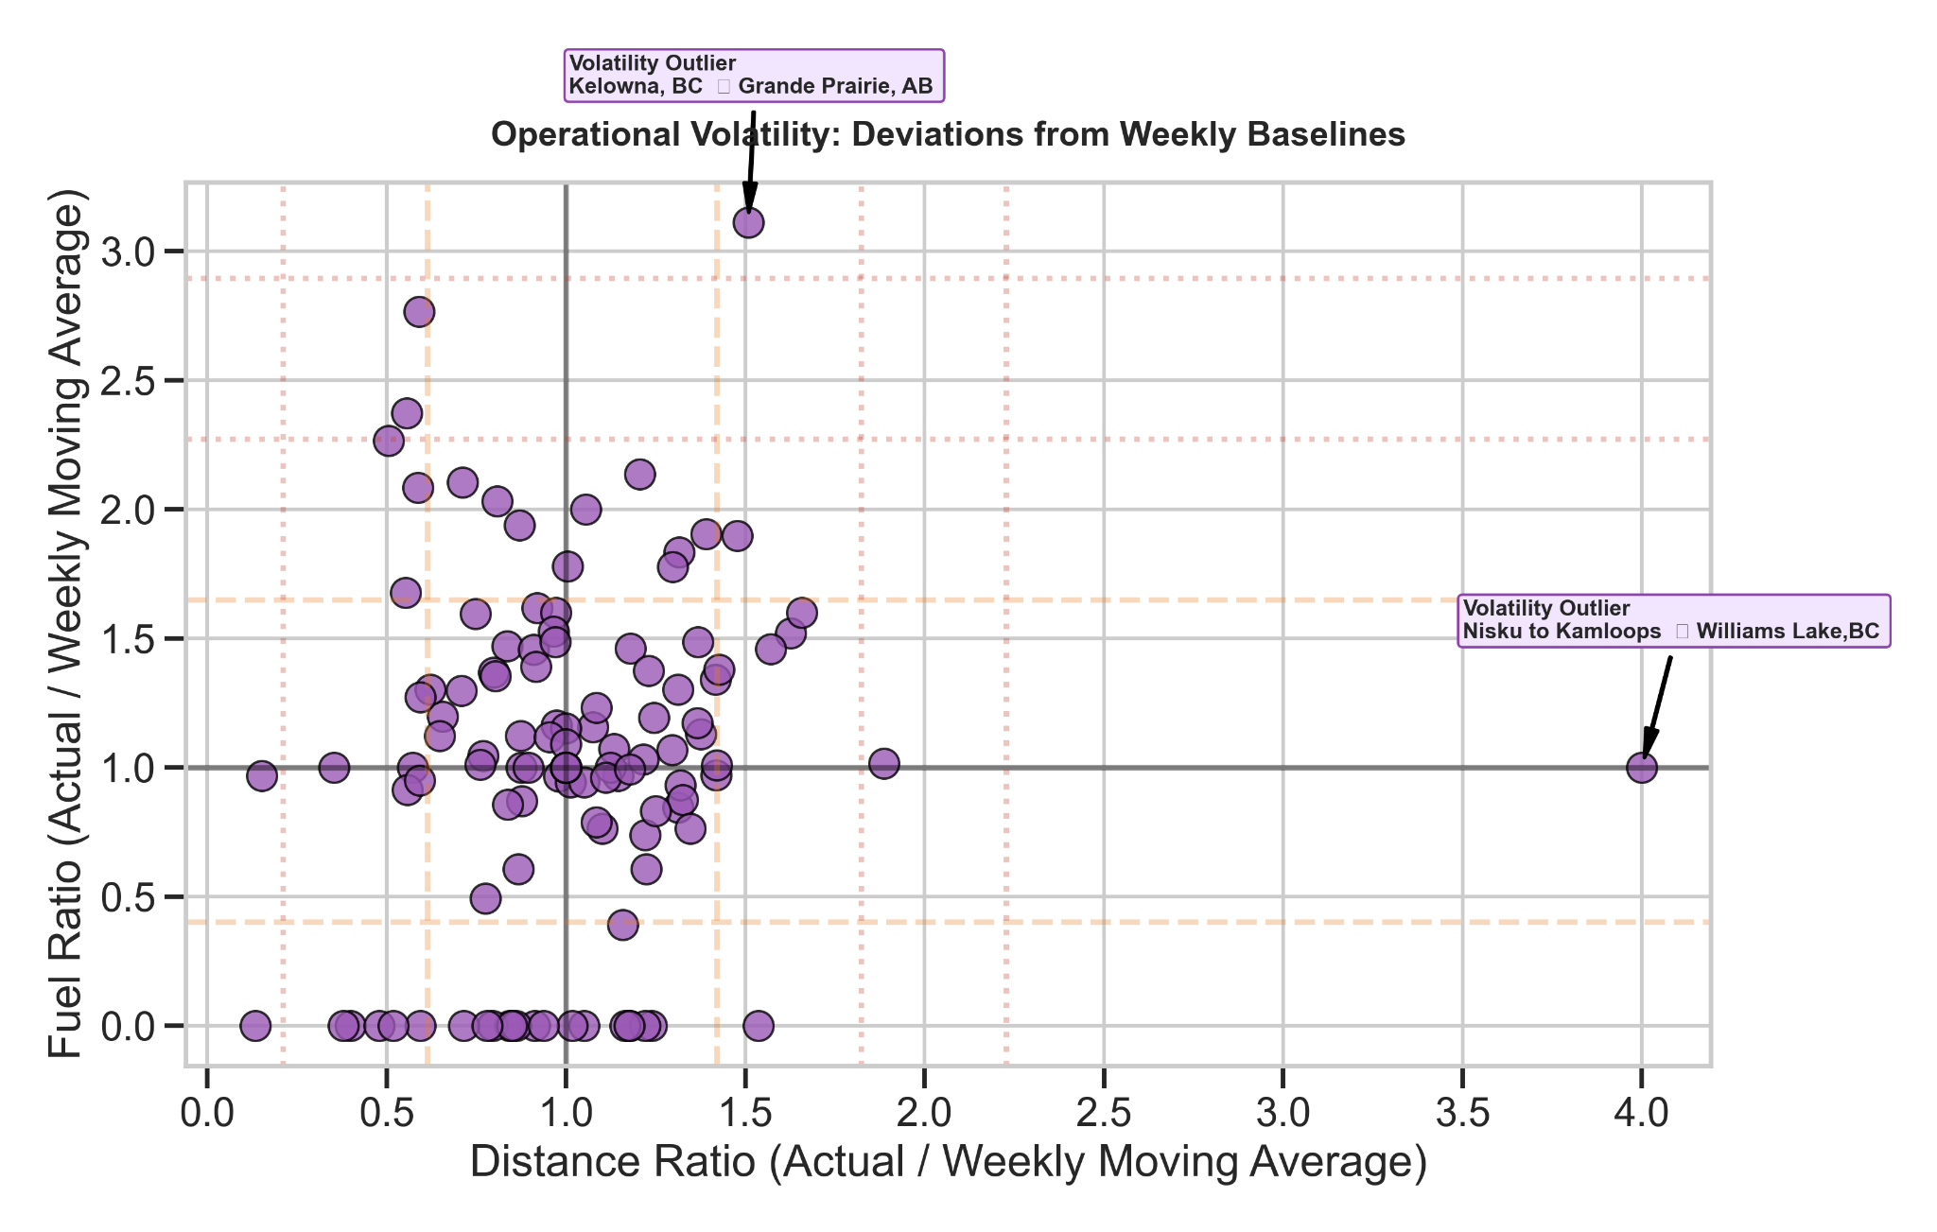
- Marginal Variance Alert (2022-07-02 | Kelowna, BC -> Grande Prairie, AB): The ratio of fuel purchased to weekly average fuel consumption crossed just past the +3σ threshold. Because it is a borderline statistical flag, this trip is routed to human auditors for secondary review to check if it represents a routine multi-day fuel lag.
- Physical Intensity Discrepancy (2022-06-06 | Nisku to Spruce Grove -> Nisku, AB): Fuel intensity spiked to an alarming 2.5 L/km. Given typical commercial equipment profiles, this massive fuel consumption rate points directly to omitted distance sheets.
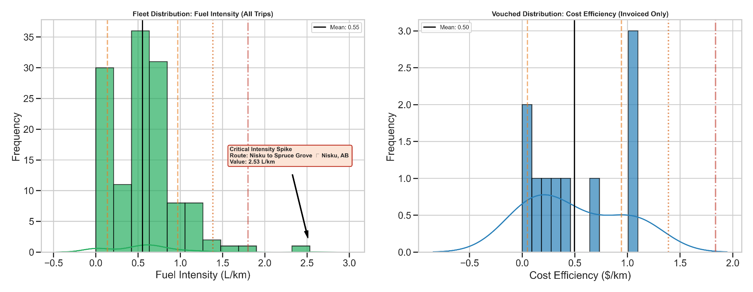

Part B: Latent Multi-Dimensional Discoveries (Stage 2)
Following the rules engine, the Isolation Forest flagged four additional trips as highly anomalous:
- 2016-05-04 (Langley -> Burnaby)
- 2021-05-08 (Barrie -> Willowdale)
- 2023-06-21 (Willowdale -> Caledon)
- 2025-11-30 (Winnipeg -> Brandon)

To maintain full transparency, a Global Feature Ablation Analysis (or Permutation Proxy) was executed to determine the exact structural drivers behind these unsupervised classifications. By systematically shuffling columns and tracking variations in the model's tree splits, we quantified the exact impact of each parameter on the anomaly isolation rate.
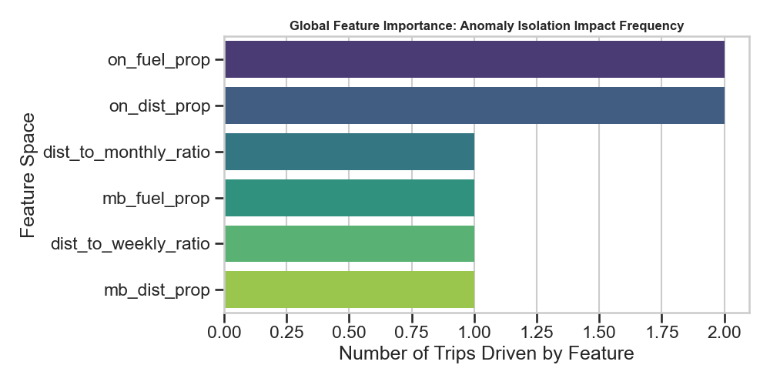
As mapped in the diagnostic summary, regional anomalies dominate these latent flags:
- Ontario Jurisdictional Scaling (on_fuel_prop & on_dist_prop): These features emerged as the highest priority drivers, dictating two full anomaly splits and indicating that these trips were isolated due to subtle geographic discrepancies along Eastern transit corridors. However, given the highly bounded volume of raw entries where both on_fuel > 0 and on_dist > 0, these classifications warrant careful secondary inspection to ensure the isolation is not an artifact of regional baseline sparsity.

- Manitoba Allocation Tracking (mb_fuel_prop & mb_dist_prop): These spatial markers directly anchored the tree split path for the late 2025 Prairies route, exposing a localized regional data variance. Because the distribution of historical logs capturing active Manitoba operational metrics (mb_fuel > 0 and mb_dist > 0) is exceptionally sparse, further verification of data continuity is required before concrete classification of this segment as a compliance violation.

- Macro Baseline Adjustments (dist_to_monthly_ratio & dist_to_weekly_ratio): These temporal scalars acted as the primary drivers behind the short-haul inter-city adjustments, proving that the model successfully caught non-linear operational drift that fell just under the radar of the simple Stage 1 Z-score checks.

